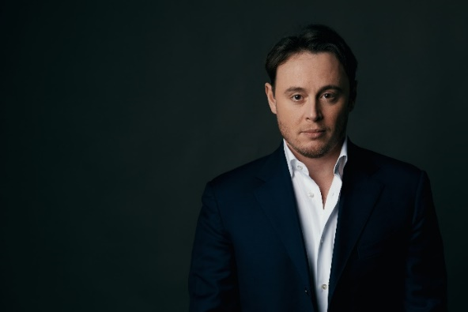
Michelle Mariotti, conductor
Michele Mariotti is the Musical Director of the Teatro dell’Opera di Roma since 2022.
Awarded the 36th Abbiati Prize as Best Orchestra Conductor, Michele is regularly invited by the main Italian and international theatres and festivals, including Milan’s La Scala, the Paris Opéra, the Wiener Staatsoper, the Royal Opera House Covent Garden in London, the Bayerische Staatsoper in Munich, the Deutsche Oper in Berlin, the Salzburg Festival, the Rossini Opera Festival in Pesaro, the Metropolitan in New York, the San Carlo in Naples, the Verdi Festival in Parma, the Amsterdam Opera, the Lyric Opera of Chicago, the Los Angeles Opera, the Wexford Festival, the Théâtre des Champs-Elysées in Paris, the Teatro Real in Madrid.
Mariotti has conducted the Gewandhaus Orchestra in Leipzig, the Orchestre National de France, the Münchner Symphoniker, the Orchestra Sinfonica Nazionale della Rai, the Danish National Symphony Orchestra, the Orchestra dell’Accademia Nazionale di Santa Cecilia in Rome, the Nederlands Philharmonisch Orkest, the Gürzenich Orchester Köln, the Filarmonica della Scala, the RTÉ National Symphony Orchestra, to name a few.
He regularly works with renowned stage directors like Mario Martone, David McVicar, Emma Dante, Davide Livermore, Damiano Michieletto, Robert Carsen, Simon Stone, Michael Mayer, Herbert Fritsch, Benedict Andrews, Tobias Kratzer, Johannes Erath.
From 2008 he was Principal Conductor, and then Musical Director until 2018 of the Teatro Comunale di Bologna, where he has led numerous concerts and dozens of opera productions, including La Bohème directed by Graham Vick that won the Music Critics Award “Franco Abbiati” for best show in 2018. He has also conducted the Orchestra and Chorus of the Teatro Comunale di Bologna on tours covering various Italian cities, Tokyo, Moscow, and Paris.
Some of his most recent engagements include his debuts at the Wiener Staatsoper and the Festival d'Aix-en-Provence conducting, respectively, Il Barbiere di Siviglia and Moïse et Pharaon. He has also conducted Verdi's Otello at the Teatro San Carlo in Naples, Macbeth at the Palau de les Arts Reina Sofía in Valencia, La bohème at the Opéra national de Paris and Dialogues des Carmélites (at the opening of the season), Aida, and Trittico Ricomposto at the Teatro dell'Opera in Rome. He also made his debut with the Orchestra dell'Accademia Nazionale di Santa Cecilia in Rome and conducted the Gürzenich Orchester Köln at the Philharmonie in Cologne and the Radio Filharmonisch Orkest at the Concertgebouw in Amsterdam.
In the coming season, in addition to his engagements with the Teatro dell'Opera di Roma and his tour of Japan with the Teatro dell'Opera di Roma Chorus and Orchestra, Mariotti will return to the Festival d'Aix-en-Provence, La Scala and to conduct the Orchestra Sinfonica Nazionale della Rai.
Michele Mariotti has completed his humanistic studies and graduated in Composition at the Rossini Conservatory in his hometown of Pesaro, where he also studied conducting with Manlio Benzi. At the same time, he graduated in Orchestra Conducting at the Accademia Musicale Pescarese with Donato Renzetti.

